Help a turtle across the road

Turtles have survived for over 200 million years – they watched the dinosaurs come and go. Now they face their biggest challenge in an uncertain future – HUMANS. Over-exploitation, habitat destruction and pollution are the biggest factors in the decline of Minnesota’s amphibian and reptile populations.

Turtles are unique in having heavy, bony armor that protects them from many predators. Their upper shell (carapace) allows them to move quickly through the water, but hinders movement on land. They have remained virtually unchanged for countless generations. The ability to pull into a shell and wait for danger to pass by has proven very successful, until the automobile.

A study at the State University of New York estimates a 10-20% mortality rate of turtles in the Great Lakes region due to traffic encounters. Given that female turtles can take up to 20 years to reach sexual maturity, the loss of such high numbers can seriously affect an entire population’s viability.

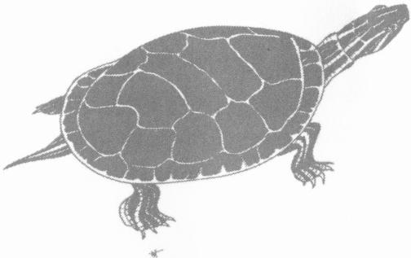

Why Cross the Road?

Turtles will move from one pond to another at any time of the year, but most turtles found on the road are females heading to a nesting site, typically May through July. This spring ritual of traveling to ancestral nesting grounds on sandy riverbanks and upland fields can be deadly when roads become a life-threatening barrier between the relative security of the wetland and the higher nesting ground. For the female who makes the trip once successfully, she must return after laying her eggs to face the gauntlet of traffic a second time. Turtles may travel over a mile to find a suitable nesting location, which could force them to cross multiple roads.

Virtually impossible to see while traveling at highway speeds, a baby turtle must make this deadly journey in the fall in order to arrive at water. These offspring have a 1% chance of surviving to breeding age.

Helping

Here are some things you can do to help Minnesota’s amphibians and reptiles:
-Don’t pollute
-Protect our natural habitats
- Educate others
- Slow down during nesting season (usually May - July)
- Limit construction and expansion of roads in and near wetlands

Realize that warm months bring more than turtles out onto our roads. Salamanders cross roads from winter uplands to wetlands on rainy spring nights. During the summer, after the sun goes down, reptiles and amphibians are attracted to roads so they can soak up the warmth on the surface when the surrounding air is cooling.

Possible solutions such as a system of culverts to divert turtles through an underground passageway may help to alleviate mortality in areas where amphibian and reptile traffic is high. You can support the addition of tunnel systems on roads with heavy turtle and frog losses by reporting these areas to the MN DNR or the Minnesota Herpetological Society.

Turtle on the Road

If you are unable to safely pull off and help the turtle to cross, move to another lane to avoid hitting the turtle. If you are able to stop, here are some tips: pull over as quickly and as safely as you can, turn on your flashers, look for oncoming cars and quickly get to the turtle. The need to move quickly isn’t because the turtle will be moving fast but rather because you need to move the turtle before another vehicle runs it over. Be cautious and sure of your own safety before trying to help a turtle across the road.

Always move the turtle to the side in the direction they were heading; this is not always towards the water. If you move a turtle back to where it came from, it will only attempt to cross the road again. Never drive the turtle to another location to release it.

Hold the turtle you have picked up away from your body – they may try to get you to put them down by releasing any liquid held in their bladder. Realize that the turtle perceives you as a threat; they can’t run or hide at this point and will try other ways to defend themselves.

Most turtles can be picked up and moved, but be cautious of the long claws, as they can scratch. Although they are unlikely to bite off a finger (as is believed possible by a snapping turtle), all turtles can inflict a very painful bite with their bird-like beak. Many turtles back up and raise their back end high off the ground in an attempt to frighten a “predator”.

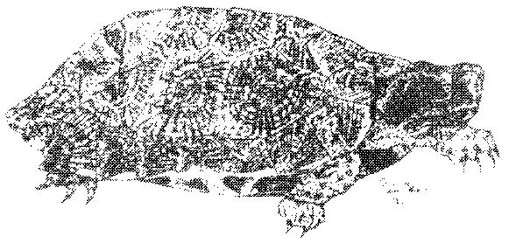

Special consideration should be given to the biggest turtle in Minnesota: the common snapping turtle. Contrary to popular opinion, snapping turtles are a fascinating animal and contribute to a well-balanced ecosystem. They can be recognized by their large overall size, head size, muscular limbs, webbed feet, long tail and saw-toothed appearance on their back. Colors may be black, brown and even green from algae growth on the shell. The common snapping turtle, given its long neck, can reach back halfway down its shell, so be careful where you have your hands. Never pick up or carry a turtle by its tail, as this can damage the vertebrae.

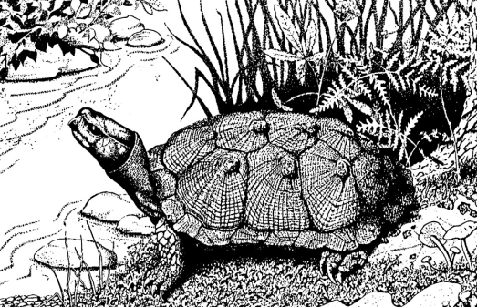

Here are some methods for moving a turtle:

-For a smaller turtle, place one hand on each side with thumbs on top and fingers below; carry it to safety but be prepared: it may scratch with its claws
-When turtles are very small, they can easily be picked up with one hand. Grab the turtle’s carapace (top shell) with your thumb on top. Keep the tail between the middle and index finger, with fingertips on the plastron (bottom shell).
-Middle-sized turtles are much easier to manipulate using all of your fingers in the above manner, but with its tail between the middle and third fingers.
-Very, very gently push the turtle across the road with a stick or other long object.
-Lift most of the turtle off the ground and very gently drag it by grabbing the shell directly above the tail.
-For large turtles, grasp them by the knees of the hind legs and face the head away from you. Never grab them by their tails!
-Get the turtle to bite a stick and gently pull it off the road. Don’t use something you want back, as they may hold on to it for a very long time before letting go. This works well with snapping turtles.
-Be a warning flag for other cars. With the utmost care for your safety, wave your hands to alert other drivers of the turtle until it crosses the road on its own.
-With great care and experience, even a large snapping turtle can be safely picked up. With one hand, firmly grasp the shell directly behind the neck and with the other, grasp the shell above the tail.

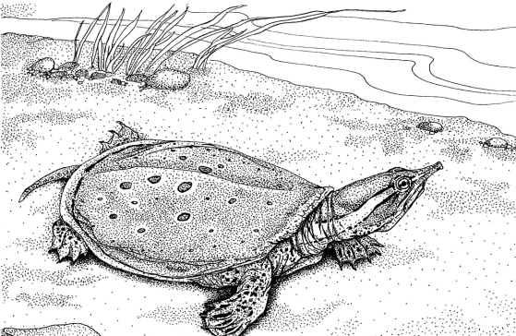

Types of turtles

Minnesota has nine species of native turtles, although few are seen or recognized other than the painted and common snapper. Two species are protected: the wood turtle and the Blanding’s turtle (both listed as threatened species). It is illegal to harm, harass or collect these species. Blanding’s turtles are dome-shaped with smooth upper shells and a hinged plastern (bottom shell). The bright yellow chin and underside of the neck is an excellent identification mark. The wood turtle gets its name from the rings on each scute on its back, which gives the shell a rough texture. They have yellow skin, but lack a hinged plastern.

All sighting of either of these turtles should be reported to the Minnesota Department of Natural Resources, Nongame Wildlife program, P.O. Box25, 500 Lafayette Road, St Paul, MN 55155. The best way to document a sighting is with a photograph. In addition, provide an exact location, habitat, weather conditions, date and the observer’s contact information.

Finding an injured turtle

Your job is to get the injured turtle to a suitable veterinary or rehab clinic capable of providing adequate care as quickly as possible. NOTE: some veterinarians will not accept injured wildlife without a sponsor. Note the location from which the turtle is being removed, so that it can be returned to the same spot after rehabilitation. Place the turtle in a container or cardboard box away from direct sunlight and excessive heat or cold. DO NOT attempt to wash the turtle, or to rinse the turtle in water. Turtles should never be released in an area other than where they were found.

Rehabilitators

Contact a wildlife rehabilitator or authorized agency as soon as possible.

- Minnesota Wildlife Haven (MWH) Minneapolis phone: 612-522-3644; pager: 612-318-0077 www.MnWildlifeHaven.org

- Wildlife Rehabilitation Clinic Univ of MN – St Paul campus – 612-624-7730 www.cvm.umn.edu/departments/ raptorwildlife.htm

- Wildlife Rehabilitation and Release, Inc (WRR) Crystal 612-822-7058

- Wildlife Rehabilitation Center Roseville phone: 651-486-9453
www.wildlife-rehab.org

FURTHER READING

Alderton, D. 1988. Turtles & Tortoises of the world. New York: Facts on File, Inc.

Breckenridge, W. J. 1944. Reptiles and Amphibians of Minnesota. Minneapolis: University of Minnesota Press

Conant, R. 1975 A Field Guide to the Reptiles and Amphibians of Eastern and Central North America. 2nd ed. Boston: Houghton Mifflin. Peterson Field Guide Series

Ernst, C., J. Lovich, and R. Barbour. 1994. Turtles of the United States & Canada. Washington: Smithsonian Institution

Klemens, M. 2000. Turtle Conservation. Washington: Smithsonian Institution

LeClere, J. Minnesota Herpetology. www.HerpNet.net/Minnesota-Herpetology

Oldfield, B. and J. J. Moriarty. 1994. Amphibians and Reptiles Native to Minnesota. Minneapolis: University of Minnesota Press

Pritchard, P. 1979. Encyclopedia of Turtles. Neptune: T.F.H. Publications

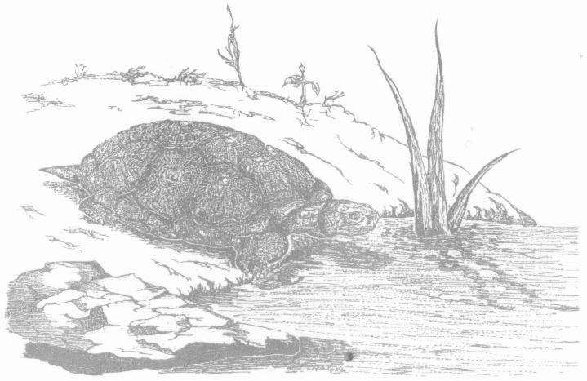

© 2010 Minnesota Herpetological Society

