FURTHER READING

Behler, J. L. and F. W. King. 1979. The Audubon Society Field Guide to North American Reptiles and Amphibians. New York: Alfred A. Knopf

Breckenridge, W. J. 1944. Reptiles and Amphibians of Minnesota. Minneapolis: University of Minnesota Press

Coffin, B. and L. Pfannmuller. 1988. Minnesota’s Endangered Flora and Fauna. Minneapolis: University of Minnesota Press

Conant, R. 1975. A Field Guide to the Reptiles and Amphibians of Eastern and Central North America. 2nd ed. Boston: Houghton Mifflin. Peterson Field Guide Series

Karns, D. 1986. Field Herpetology Methods for the Study of Amphibians and Reptiles in Minnesota. Minneapolis: J.F. Bell Museum of Natural History

LeClere, J. Minnesota Herpetology. www.HerpNet.net/Minnesota-Herpetology

Oldfield, B. and J. J. Moriarty. 1994. Amphibians and Reptiles Native to Minnesota. Minneapolis: University of Minnesota Press

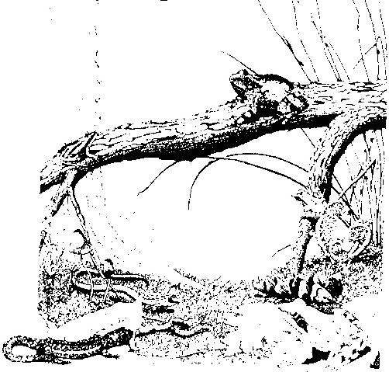

© 2010 Minnesota Herpetological Society

Minnesota’s Endangered, Threatened & Special Concern Amphibians & Reptiles

Minnesota Herpetological Society
c/o Bell Museum of Natural History
10 Church Street South East
Minneapolis, Minnesota, 55455



For more information
Call: 612-326-6516

www.MnHerpSoc.Org
Minnesota is home to at least 50 species of herpetofauna (amphibians and reptiles). These species live in a wide variety of habitats and are dependent upon their specialized habitats for survival. Sixteen of the fifty species are “listed” in Minnesota. This means that these particular species are placed in one of the three following categories: Endangered, Threatened or Special Concern. This pamphlet will briefly discuss what these categories mean, provide a list of these species placed in their respective categories and provide a little information about why they are listed. There will be information at the end of the pamphlet about what to do if you find a listed species in Minnesota.

The DNR defines the categories as follows:

Endangered: A species threatened with extinction throughout all or a significant portion of its range. A species threatened with extirpation within Minnesota and dependant on a scarce, sensitive and/or exploited habitat.

Threatened: A species likely to become Endangered within the foreseeable future throughout all or a significant portion of its range or in Minnesota.

Special Concern: A species that is uncommon in Minnesota and/or has unique or highly specific habitat requirements, or is on the periphery of its range. Also included are species that are likely to be collected for the pet trade or were formerly listed as Endangered or Threatened and their populations are now stable but are being monitored.

Although Species of Special Concern are not protected by law in Minnesota, Threatened and Endangered species are protected by law against harming, collecting and/or keeping in captivity. Any activities involving these species require a permit from the DNR.

Endangered

Northern Cricket Frog
Acris crepitans
Cricket frogs were formerly common in both southwest and southeastern Minnesota until the early 1980’s. Since that time, the only specimens found in Minnesota were in a small population in Hennepin County, discovered in 1998. This population is outside the former range and is possibly introduced. Another population recently reported in Winona County appears healthy and is situated within their former range. This frog has declined in other states, such as Iowa and Wisconsin, as well.

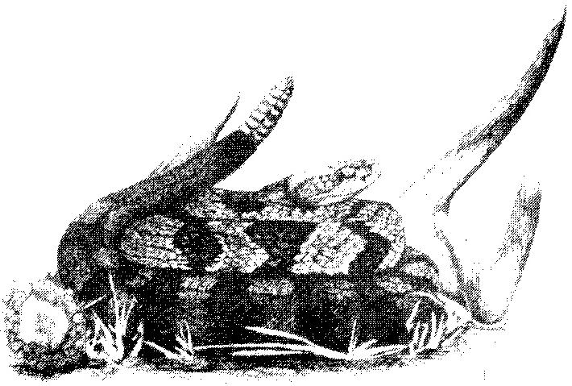

Massasauga Rattlesnake
Sistrurus catenatus
Venomous. This unique species has declined throughout most of its former range, mainly due to habitat destruction and mismanagement. The massasauga has never been properly documented in Minnesota, but there are several dubious sightings. If it does live in Minnesota, it would be found in the marshy areas of extreme southeastern Minnesota. They require marshy habitats with associated upland prairies. Since this species overwinters in crayfish burrows, healthy crayfish populations are a necessary component.

Threatened

Wood Turtle
Glyptemys insculpta
The wood turtle is found sporadically along the eastern edge of Minnesota, where it prefers streams and river habitats with mature bottomland forest and grassland edge. It is likely that this turtle never had a large range in Minnesota, and its current habitat is rapidly disappearing.

Blanding’s Turtle
Emydoidea blandingii
Although this turtle is widespread in our state, the open prairie marshes in which it lives are quickly being developed. The marshes and sandy prairies in central Minnesota are disappearing at an alarming rate.

Timber Rattlesnake
Crotalus horridus
Venomous. Timber rattlesnakes have suffered much at the hands of humans. They have a very restricted range in Minnesota and are only found in the blufflands of the southeast edge of the state. They were bountied until 1989 and their preferred open bluff prairie habitat is threatened by woody encroachment. They are still persecuted by humans, and many populations have been extirpated.

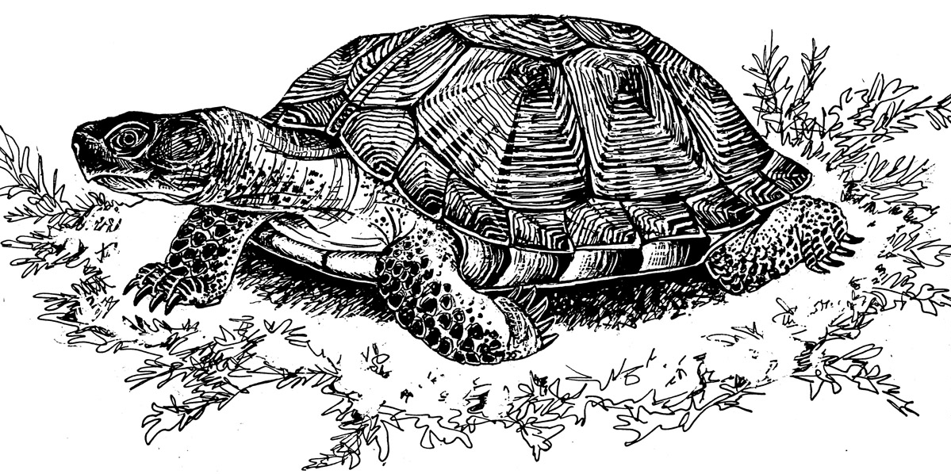

Special Concern

Smooth Softshell Turtle
Apalone mutica
This aquatic species of turtle looks very much like its more common cousin, the spiny softshell. Until the 1990’s, it was documented in only a few counties along the Minnesota and Mississippi Rivers. Surveys have shown that more populations exist, but it is still being closely monitored. The sandy portions of these rivers and the associated sandbars are important habitat components.

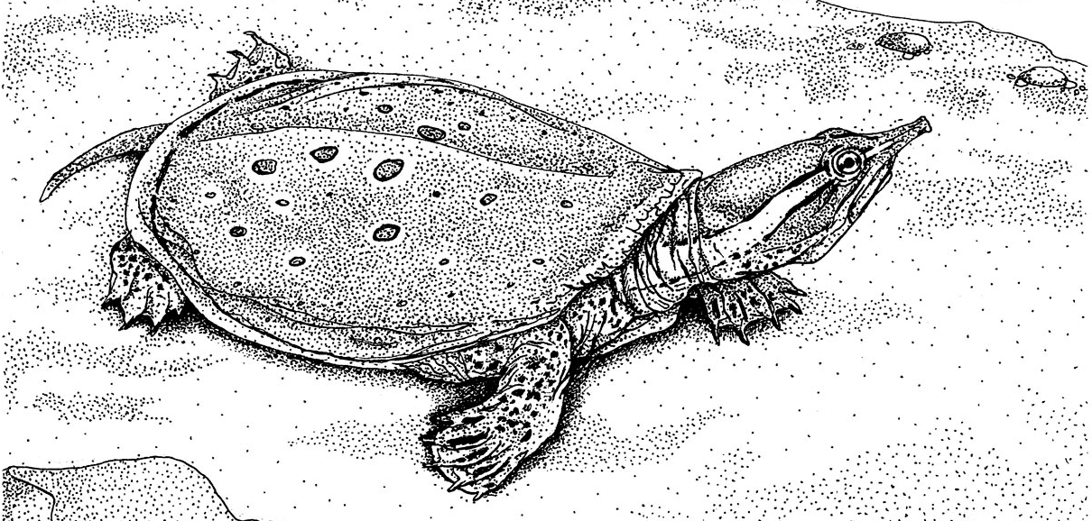

Snapping Turtle
Chelydra serpentina
This aggressive turtle is well known and found statewide in Minnesota. It is seemingly very common but nonetheless, this species is declining, due in part to pollution, habitat destruction and many years of unrestricted harvest. Recently, a moratorium has been placed on the harvest of snapping turtles in Minnesota.

Five-lined Skink
Plestiodon fasciatus
This colorful lizard was formerly listed as Endangered in Minnesota. Subsequent searches have found many new populations in both western Minnesota along the Minnesota River and in southeastern Minnesota, but the populations are still being monitored. This species’ habitat requirements parallel those of the timber rattlesnake.

Four-toed Salamander
Hemidactylium scutatum
This tiny salamander was first reported in Minnesota in 1994. New populations in many counties have since been found, but more data must be collected to determine this species’ status. It requires the sphagnum bog habitats found in northeastern Minnesota.

Racer
Coluber constrictor
This is Minnesota’s fastest snake. It is a nervous species that is not often found near human habitation in Minnesota. It lives in the southeast corner and along the Minnesota River to the central part of the state. It was originally listed because of concerns due to over-collection for the pet trade, but the more pressing problem seems to be the vegetative encroachment or destruction of its open field habitat.

Rat Snake
Pantherophis obsoletus
The rat snake is a beautiful snake with a very restricted range in Minnesota and was probably never common here. It is found in extreme southeastern Minnesota along the heavily wooded blufflands. Although the few existing populations seem to be stable, this cannot be assumed. Therefore, it is being monitored. Any sightings of this snake should be reported.

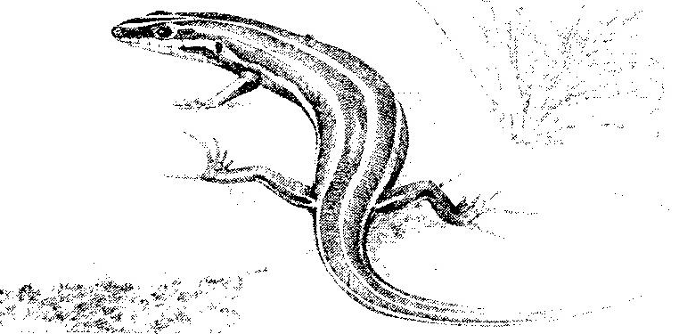

Western Hognose Snake
Heterodon nasicus
This species fits the same scenario as the Blanding’s turtle. It prefers the open sand plains in central and southwestern Minnesota and the gravelly soils in the west. The flat open sandy areas are the first to be farmed or developed and many populations have been lost. Western hognose snakes still occur on protected lands and the few undeveloped lands with appropriate habitat. Over-collection is also a problem for this species.

Gopher Snake - “Bullsnake”
Pituophis catenifer
This is Minnesota’s largest snake species and although it is widespread in the state, it faces the same problems as both the Blanding’s turtle and the western hognose snake. This species must have large tracts of native sand prairie to support a healthy population. Over-collection is also a problem for the bullsnake.

Lined Snake
Tropidoclonion lineatum
This small, garter snake look-alike has only been documented in one location in the entire state of Minnesota: Rock County in the extreme southwest corner of the state. Although searches have not turned up any new locations, it could occur in other open prairie areas with exposed quartzite outcroppings. Any sightings should be reported. A double row of dark half moon markings on the belly distinguishes the lined snake from garter snakes.

What to do if a listed species is found

The best thing to do is take photographs of the animal and leave it where it is. Do not collect it and if it is venomous (as in the massasauga or timber rattlesnake), do not attempt to handle or remove it. A good, identifiable picture can be taken at a safe distance. Record the exact location, date, habitat and weather conditions, and include your name with the proper contact information. Reports can be sent to the MN DNR. The public has provided excellent information and has assisted in recording species in new counties and monitoring populations. Your contributions are greatly appreciated.

Text by Jeff LeClere
Edited by Christopher E. Smith, Ellen Heck

